An oscillator circuit is an electronic circuit that produces a periodic, alternating waveform from a DC source, without any external input. It's a fundamental building block in many electronic devices, generating signals for various applications. Oscillators typically consist of an amplifier and a frequency-selective component, like an RC or LC network, that determines the output frequency.

The oscillator converts the DC (direct current) from the power supply to an AC (alternating current), used in many electronic devices. The signal used in the oscillator is a sine wave & the square wave. The best examples of an oscillator are, the signals are broadcasted by the television transmitter and radio, CLKs which are used in the computers and also in the video games.

The oscillator works on the principle of oscillation and it is a mechanical or electronic device. The periodic variation between the two things is based on the changes in energy. The oscillations are used in watches, radios, metal detectors, and many other devices that use the oscillators.

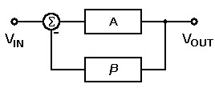

*Oscillator*

Principle of Oscillators

* The oscillator converts the direct current from the power supply to an alternating current and they are used in many electronic devices. The signals used in the oscillators are a sine wave and the square wave. Some of the examples are the signals are broadcasted by the radio and television transmitter, clocks which are used in computers and in video games.

Types of Oscillator Circuits

* There are two types of oscillator circuits available they are linear and nonlinear oscillators. The linear oscillators give the sinusoidal input. The linear oscillators consist of a mass m and its force in the linear equilibrium. By applying the hook’s low the spring creates the force that i9s in linear for small displacements.

The different types of oscillator circuits are mentioned below and some of them are explained.

* Armstrong Oscillator
* Crystal Oscillator
* Hartley oscillator
* RC Phase Shift Oscillator
* Colpitts Oscillators
* Cross-Coupled Oscillator
* Dynatron Oscillator
* Meissner Oscillator
* Optoelectronic Oscillator
* Phase Shift Oscillator
* Wien Bridge Oscillator
* Robinson Oscillator
* Tri-Tet Oscillator

**Armstrong Oscillator**

The Armstrong oscillator is an LC electronic oscillator and to generate this oscillator we are using the inductor and the capacitor. In 912 the US engineer Edwin Armstrong has invented the Armstrong oscillator and it was the first oscillator circuit and also in 1913, this oscillator was used in the first vacuum tube by Alexander Meissner who was an Austrian engineer.

A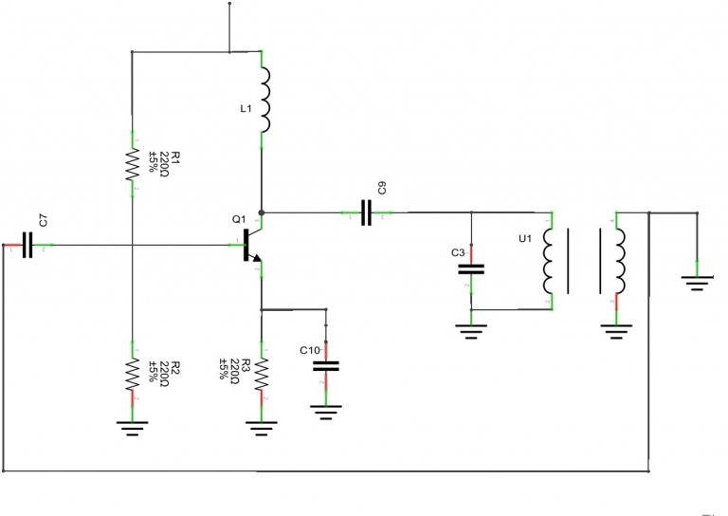

Armstrong Oscillator

**Hartley Oscillator**

The features of the Hartley circuit are the tuned circuit consists of a single capacitor in parallel with the two inductors which are in series. From the center connection of the two inductors for oscillation purposes, the feedback signal is taken. Follow the below link to know more about Hartley Oscillator Circuit and Its Working

The Hartley oscillator is parallel to the Colpitts apart from that it uses a pair of tapping coils as an alternate of two tapped capacitors. From the above circuit the output voltage is developed across the inductor L1 and the feedback voltages are across the inductor L2. The feedback network is given in the mathematical expression which is given below

Feedback network = XL2 / XL1 = L 2 / L 1

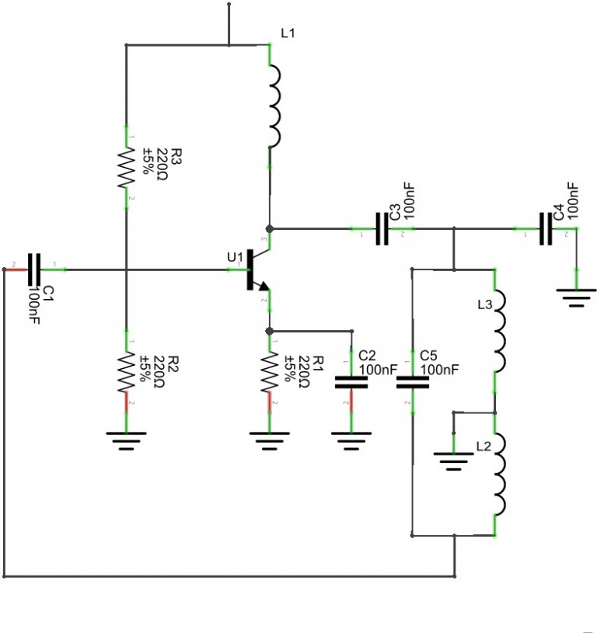

*Hartley Oscillator*

***Colpitts Oscillator***

The Colpitts circuits consist of gain devices such as the bipolar junction, field-effect transistor, operational amplifier, and vacuum tubes. The output is connected to an input in a feedback loop it has a parallel tuned circuit and it functioned as a band-pass filter is used as a frequency of the oscillator. This oscillator is an electrically dual of the Hartley oscillator hence the feedback signal is taken from the inductive voltage divider it has two coils in the series.

The following circuit diagram shows the common base Colpitts circuit. The inductor L and both the capacitors C1 & C2 are in series with the parallel resonant tank circuit and it gives the frequency of the oscillator. The voltage across the C2 terminal is applied to the base-emitter junction of the transistor to create feedback oscillations.

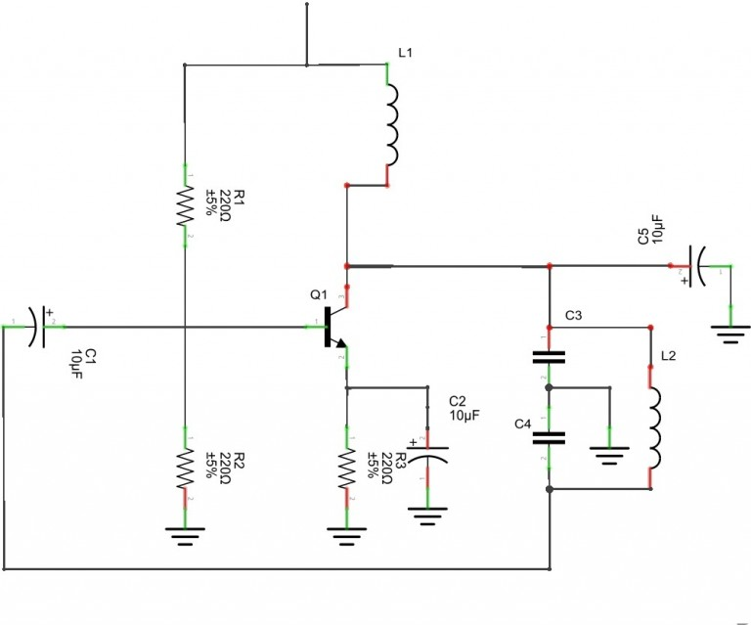

*Colpitts Oscillator*

**Multi-Wave Oscillator**

The multi-wave oscillator was invented by the French engineer Georges Lakhovsky in year of 1920 to 1940. He showed that the nucleus of the cell with the filaments stands, it is very similar to the electronic oscillator and it has the capability of receiving & sending vibratory information. The multi-wave oscillators are experimental, research for the historical instrument, and there is no medical claim is made. The multi-wave oscillator unit presents the printed circuit board Golden ratio antenna.

**Fundamentals**

* Oscillator circuits generate continuous, periodic waveforms without needing an external input. They are used in devices like clocks, radios, and communication systems.
* They consist of an amplifier, a feedback network, and frequency-determining components (R, C, L) that set the oscillation frequency.
* Common types include RC oscillators (low-frequency), LC oscillators (high-frequency), **

crystal oscillators (high stability), and relaxation oscillators (non-sinusoidal waves).

* To sustain oscillation, the Barkhausen criterion must be met: loop gain = 1 and total phase shift = 0° or 360°.
* Oscillators are used for timing, signal generation, and frequency control in many electronic systems.